SHAGUFA ANJUM
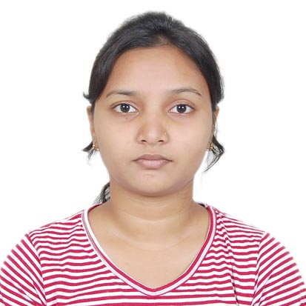
MBA (MASTERS IN BUSINESS ADMINISTRATION)
Contact No: +91-8763433973
E-Mail: shagufa.anjum@gmail.com
Correspondence Address:
C/o- MD. Aiyub Alam
At/po- rajgangpur, O.C.L Colony 1/57
Dist- Sundergarh
Odisha -770017

Career Objective
To develop my career as a manager where I will be a valuable team member, contributing quality ideas and work and where there is an ample scope for individual as well as organizational growth. I wish to associate myself with an organization to which I can give my best and which elicits the best out of me, which offer me an opportunity to continually grow and learn each day, where the system and policies naturally motivate people to go that extra mile with a smile

Education Qualification

- MBA in HR
Aligarh Muslim University, centre- Kishanganj
- B.Tech(Electrical and Electronics Engineering)
Koustuv Institute of Technology, University-BPUT, Bhubaneswar
CGPA-7.54
- Senior Secondary
Dalmia Vidya Mandir, Rajgangpur, Odisha (C.B.S.E, 62%)
- Secondary
Dalmia Vidya Mandir, Rajgangpur, Odisha (C.B.S.E, 74.4%)

Skill Set

Languages known: C, C++
Training skills:
- Industrial training in O.C.L
- Programmable Logic Controller(PLC) in CTTC
- SCADA,HMI, AC DRIVES ,PLC( SIEMENS,MITSUBISHI, ALLEN BRADLEY,MESSUNG) in ACS
- Summer Internship in O.C.L

Project

Wireless surveillance system for machine monitoring system

In this project a model is designed with a single cluster sensor tooled the central by monitoring station for its status and also the control of operation of stand by device can be made from the control room. It is an application design to monitor the individual device at the time of requirement.

Hobbies

- Painting
- Cooking

Personal profile

Name: Shagufa Anjum
Date of birth: 22th august 1990
Gender: Female
Languages Known: English, Hindi and Oriya
Permanent address: At-1/57 O.C.L COLONY
P.O - Rajgangpur
Dist- Sundergarh
State- Odisha
Pin-770017
Declaration

I hereby declare that the above information is true to the best of my knowledge and concern.

Date:

Place:
(Signature)

